***Week 15 Coding***

***Program 1***

*Given an array of integers, reverse the given array in place using an index and loop rather than a built-in function.*

*Example*

*arr = {1, 3, 2, 4, 5]*

*Return the array [5, 4, 2, 3, 1] which is the reverse of the input array.*

*Function Description*

*Complete the function reverseArray in the editor below.*

*reverseArray has the following parameter(s):*

*intarr[n]: an array of integers*

*Return*

*int[n}: the array in reverse order*

*Constraints*

*100*

*O < arr[i] 100*

*Input Format For Custom Testing*

*The first line contains an integer, n, the number of elements in arr.*

*Each line i of the n subsequent lines (where O i < n) contains an integer, arrlil.*

*Sample Case O*

*Sample Input For Custom Testing*

*5*

*1*

*3*

*2*

*4*

*5*

*Sample Output*

*5*

*4*

*2*

*3*

*1*

*Explanation*

*The input array is [1, 3, 2, 4, 5], so the reverse of the input array is [5, 4, 2, 3, 1].*

*Sample Case 1*

*Sample Input For Custom Testing*

*4*

*17*

*10*

*21*

*45*

*Sample Output*

*45*

*21*

*10*

*17*

*Explanation*

*The input array is [17, 10, 21, 451, so the reverse of the input array is [45, 21, 10, 17].*

***Coding***

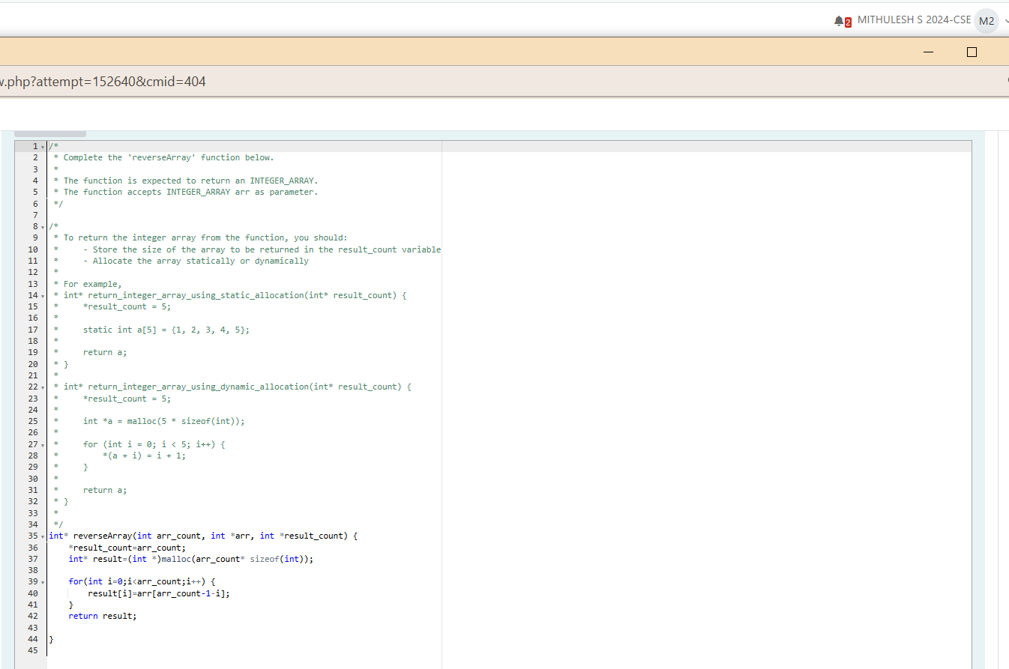

***Output***

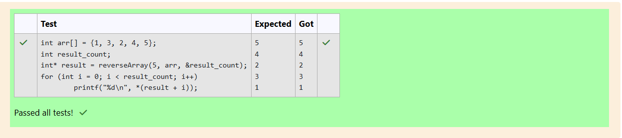

***Program 2***

*An automated cutting machine is used to cut rods into segments. The cutting machine can only hold a rod of minLength or more, and it can only make one*

*cut at a time. Given the array lengths[] representing the desired lengths of each segment, determine if it is possible to make the necessary cuts using this*

*machine. The rod is marked into lengths already, in the order given.*

*Example*

*lengths = [4, 3, 2]*

*minLength = 7*

*The rod is initially sum(lengths) = 4 + 3 +2 = 9 units long. First cut off the segment of length 4 +3 = 7 leaving a rod 9 - 7=2. Then check that the length 7*

*rod can be cut into segments of lengths 4 and 3. Since 7 is greater than or equal to minLength = 7, the final cut can be made. Return 'Possible".*

*Example*

*lengths = [4, 2, 3]*

*minLength = 7*

*The rod is initially sum(lengths) = 4 + 2 + 3 = 9 units long. In this case, the initial cut can be of length 4 or 4 + 2 = 6. Regardless of the length of the first cut, the remaining piece will be shorter than*

*minLength. Because n - 1 = 2 cuts cannot be made, the answer is *Impossible".*

*Function Description*

*Complete the function cutThemAll in the editor below.*

*cutThemAll has the following parameter(s):*

*int lengthsfn]: the lengths of the segments, in order*

*int minLength: the minimum length the machine can accept*

*Returns*

*string: "Possible" if all n-1 cuts can be made. Otherwise, return the string "Impossible".*

*Constraints*

*105*

*109*

*1 lengths{ij 109*

*The sum of the elements of lengths equals the uncut rod length.*

*Input Format For Custom Testing*

*The first line contains an integer, n, the number of elements in lengths.*

*Each line i of the n subsequent lines (where O i < n) contains an integer, lengths(i].*

*The next line contains an integer, minLength, the minimum length accepted by the machine.*

*Sample Case O*

*Sample Input For Custom Testing*

*STDIN*

*Function*

*lengths[] size n = 4*

*4*

*3*

*5*

*4*

*3*

*9*

*lengths[]*

*-4 minLength—*

*-9*

*Sample Output*

*Possible*

*Explanation*

*The uncut rod is 3 + 5 + 4 + 3 = 15 units long. Cut the rod into lengths of 3 + 5 + 4 = 12 and 3. Then cut the 12 unit piece into lengths 3 and 5 + 4 = 9. The remaining segment is 5 + 4*

*that is long enough to make the final cut.*

*Sample Case I*

*Sample Input For Custom Testing*

*= 9 units and*

*STDIN*

*3*

*5*

*6*

*2*

*12*

*Function*

*lengths[] size n = 3*

*minLength*

*= 12*

*Sample Output*

*Impossible*

*Explanation*

*The uncut rod is 5 + 6 + 2 = 13 units long. After making either cut, the rod will be too short to make the second cut.*

***Coding***

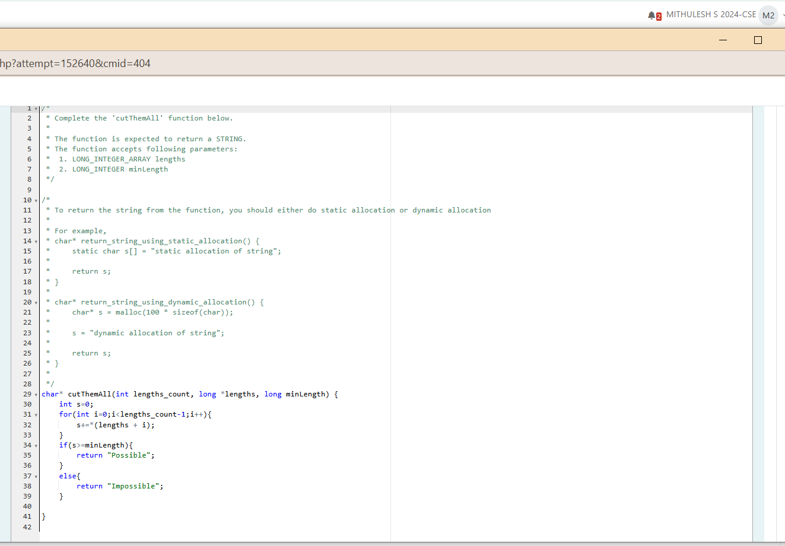

***Output***

